1. 11

2. 14

3.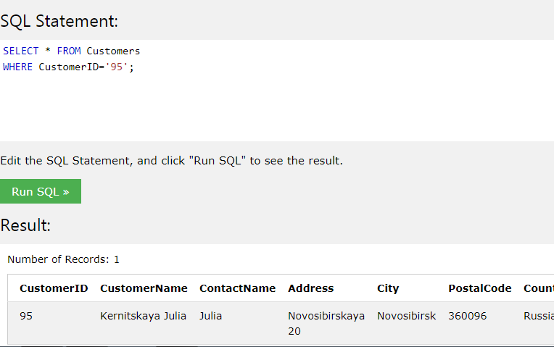

4.

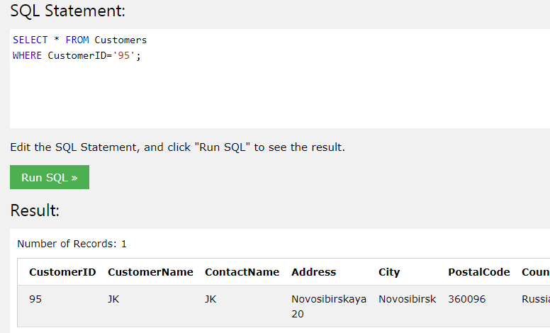

5.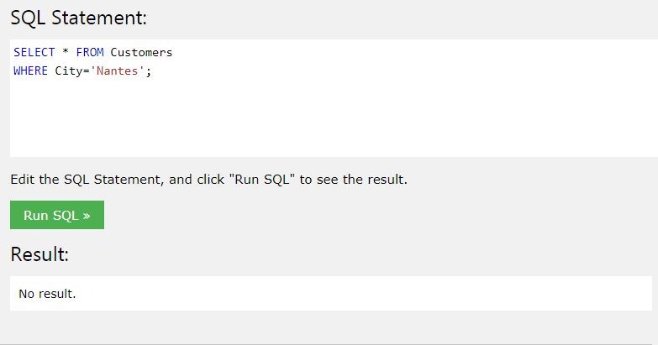

6.Запрос:

SELECT Orders.OrderID   
FROM Orders   
INNER JOIN Employees ON Orders.EmployeeID=Employees.EmployeeID WHERE Employees.FirstName='Steven'